ASSIGNMENT OF REMEDIAL MATHEMATICS

Part of the degree of
BACHELOR OF PHARMACY

Submitted to
SNEHA AGGARWAL
Submitted by:
Name-Madhur Partap
Roll no /SAP ID -1000025769
Section F

SCHOOL OF COMPUTRING
DIT UNIVERSITY, DEHRADUN
(State Private University through State Legislature Act No. 10 of 2013 of Uttarakhand and approved by UGC)
Mussoorie Diversion Road, Dehradun, Uttarakhand - 248009, India.
OCTOBER, 2025

CANDIDATES DECLARATION

I hereby certify that the work, which is being presented in the Report, entitled “Bank Management System”, in partial fulfilment of the requirement as part of the course Programming for Problem Solving of the Degree of Bachelor of Computer Science and Engineering and submitted to the DIT University is an authentic record of my work carried out during the period 12/10/2024 to 07/11/2024 under the guidance of Ms. Preeti gupta.

Date: 25-10-2024
Signature of the Candidate

TABLE OF CONTENT
CHAPTER PAGE No.
- Introduction to Bank Management System 5
- Problems in Bank Management System 6
- Project description 9
- Method of implementation. 13

Rules for Fonts in chapters
- Chapter heading 16, Times new Roman
- Sub Headings 14
- Text 12, Times new roman
- Each figure caption – 10, times new roman
- Line spacing 1.5

Introduction to Bank Management System
A Bank Management System (BMS) is a comprehensive software solution designed to streamline and automate various banking operations. It enhances the efficiency and accuracy of services offered by banks, ensuring better customer satisfaction and improved operational control.

The system encompasses functionalities such as account management, transaction processing, loan management, customer relationship management, and reporting. By integrating these processes, a BMS helps financial institutions manage their resources effectively, minimize errors, and comply with regulatory requirements.

With the increasing demand for digital banking solutions, the BMS also supports online transactions and mobile banking, allowing customers to access services conveniently. Overall, a robust Bank Management System plays a crucial role in the modern banking landscape, facilitating both operational efficiency and enhanced customer engagement.

Problems with Bank Management System

1.Data Security Issues
Vulnerabilities can lead to cyberattacks, risking sensitive customer information and damaging trust.
- Example: A bank management system may be vulnerable to cyberattacks, leading to unauthorized access to sensitive customer information. For instance, a data breach could expose account numbers, personal identification details, and transaction histories, risking customer trust and regulatory penalties.

2.System Downtime
Frequent outages disrupt banking services, preventing customers from accessing accounts or completing transactions.
- Example: Frequent outages can disrupt banking services. For example, if a bank’s online platform goes down during peak hours, customers may be unable to access their accounts or conduct transactions, leading to frustration and loss of business.

3.Integration Challenges
Legacy systems may struggle to work with new technologies, causing data inconsistencies and user experience issues.
- Example: Legacy systems may not integrate well with newer technologies. A bank may struggle to connect its existing account management software with a new mobile app, causing inconsistencies in data and user experience.

4.User Interface Complexity
Complicated interfaces can deter customers from using online banking, leading to a preference for traditional methods.
- Example: A complicated user interface can deter customers from using online banking services. If the system requires multiple steps for simple transactions, customers may abandon the process, preferring traditional banking methods instead.

5.Regulatory Compliance
Insufficient compliance features can result in violations of laws, exposing the bank to legal penalties and reputational damage.
- Example: Banks must adhere to strict regulations like GDPR or AML laws. A management system lacking proper compliance features could inadvertently facilitate illegal transactions or mishandle personal data, leading to severe legal repercussions.

6.Scalability Issues
A system that cannot scale may become slow during high-demand periods, negatively affecting service quality.
- Example: As a bank grows, its management system must handle increased transactions and users. If the system is not scalable, it may become slow or unresponsive, affecting service quality during high-demand periods, such as holiday seasons.

7.Customer Support Limitations
Lack of effective support features can lead to long wait times for issue resolution, frustrating users.
- Example: If the system does not include effective customer support features, customers may face difficulties resolving issues. For instance, a lack of live chat support can lead to long wait times for assistance, frustrating users.

8.Inadequate Reporting Tools
Limited analytics capabilities hinder management’s ability to make informed decisions and identify trends.
- Example: A bank management system may lack advanced analytics and reporting capabilities. Without detailed insights into customer behavior or transaction trends, management may struggle to make informed decisions or identify potential issues.

9.Transaction Processing Delays
Inefficiencies can cause delays in transactions, leading to customer dissatisfaction and cash flow issues.
- Example: Delays in transaction processing can cause customer dissatisfaction. For instance, if fund transfers take longer than expected due to system inefficiencies, customers may experience cash flow issues.

10.Training and Adaptation
Insufficient training can lead to errors by staff in handling transactions and customer inquiries, impacting service delivery.
- Example: Employees may find it challenging to adapt to new systems or software updates. If training is insufficient, staff may make errors in processing transactions or managing customer inquiries, negatively impacting service delivery.

Addressing these issues is essential for improving the overall efficiency and reliability of a Bank Management System, ultimately leading to enhanced customer satisfaction and trust in banking services.

Project Description
Purpose:
The purpose of the Bank Management System (BMS) is to streamline banking operations, enhance customer service, and improve overall efficiency within the banking environment. The system aims to automate various processes such as account management, transaction processing, loan management, and reporting, thereby reducing manual errors, ensuring data security, and providing customers with convenient access to banking services.

Problem statement:

Many banks face challenges related to inefficient manual processes, data security vulnerabilities, and outdated legacy systems. These issues lead to poor customer experience, increased operational costs, and compliance risks. The Bank Management System seeks to address these problems by providing a centralized platform that automates transactions, enhances data security, ensures regulatory compliance, and facilitates better customer engagement.

System Requirements:
- Hardware requirements:-
- Server:
Processor: Minimum Intel Xeon or equivalent
RAM: 16 GB or higher
Storage: 500 GB SSD or higher
Network: High-speed internet connection

- Client Machines:
Processor: Minimum Intel i3 or equivalent
RAM: 4 GB or higher
Storage: 100 GB HDD or higher
Network: Reliable internet connection

- Software Requirements:
- Operating System:
Windows Server (2016 or higher) or Linux (Ubuntu/CentOS)
- Database Management System:
MySQL, PostgreSQL, or Oracle Database

- Development Environment:
Programming Language: Java, Python, or C#
Framework: Spring, Django, or ASP.NET

- Web Technologies:
HTML, CSS, JavaScript for the frontend

- Frameworks: React, Angular, or Vue.js (optional)

- Security Software:
Firewall and antivirus software for protecting sensitive data

- Backup Solutions:
Regular data backup tools or cloud storage solutions
This comprehensive setup will ensure that the Bank Management System operates efficiently and securely, catering to the needs of both the bank and its customers.

Software requirements:-
- Operating System:
Windows Server (2016 or higher) or Linux (Ubuntu/CentOS)
- Database Management System:
MySQL, PostgreSQL, or Oracle Database

- Development Environment:
Programming Language: Java, Python, or C#

- Framework: Spring, Django, or ASP.NET

- Web Technologies:
HTML, CSS, JavaScript for the frontend

- Frameworks: React, Angular, or Vue.js (optional)

- Security Software:
Firewall and antivirus software for protecting sensitive data

- Backup Solutions:
Regular data backup tools or cloud storage solutions
This comprehensive setup will ensure that the Bank Management System operates efficiently and securely, catering to the needs of both the bank and its customers.

Methods and Implementation

- Modules Overview
- Customer Management

- Customer registration and profile management
- Account types (savings, checking, etc.)
- Account Management

- Account creation, closure, and details update
- Balance inquiry and statement generation
- Transaction Management

- Fund deposits and withdrawals
- Fund transfers between accounts
- Transaction history
- Loan Management

- Loan application and approval process
- Repayment tracking and management
- User Authentication

- Admin and customer login
- Role-based access control
- Reporting

- Generate various financial reports (daily transactions, loan summaries)
- Customer activity reports
- 3. Technical Specifications
- Technologies Used

- Programming languages (Java, Python, etc.)
- Database (MySQL, PostgreSQL, etc.)
- Frameworks (Spring, Django, etc.)
- System Architecture

- Client-server model
- RESTful API design (if applicable)
- 4. User Interface Design
- Wireframes: Basic designs for customer and admin interfaces.
- User Experience: Navigation flow and usability considerations.
- 5. Security Measures
- Data encryption
- Secure authentication methods
- Regular audits and compliance checks
- 6. Testing and Maintenance
- Testing Strategies

- Unit testing
- Integration testing
- User acceptance testing (UAT)
- Maintenance Plan

- Regular updates and bug fixes
- User feedback mechanism
- 7. Conclusion
- Summary of key points
- Future enhancements and scalability considerations
- 8. References
- Chatgpt , Wikipedia, etc.

- Pseudocode
#include <stdio.h>
#include <string.h>

// Structure for a customer account
Typedef struct {
Char name[50];
Char accountType[20];
Int accountNumber;
Float balance;
} CustomerAccount;

// Function to create a new account
Void createAccount(CustomerAccount* account) {
Printf(“Enter customer name: “);
Fgets(account->name, sizeof(account->name), stdin);
Account->name[strcspn(account->name, “\n”)] = 0; // Remove newline
Printf(“Enter account type (savings/current): “);
Fgets(account->accountType, sizeof(account->accountType), stdin);
Account->accountType[strcspn(account->accountType, “\n”)] = 0; // Remove newline
Account->accountNumber = 1001; // Fixed account number
Account->balance = 0.0; // Start with zero balance
}

// Function to deposit money
Void deposit(CustomerAccount* account, float amount) {
If (amount > 0) {
Account->balance += amount;
Printf(“Deposit successful. New balance: %.2f\n”, account->balance);
} else {
Printf(“Invalid deposit amount.\n”);
}
}

// Function to withdraw money
Void withdraw(CustomerAccount* account, float amount) {
If (amount > 0 && amount <= account->balance) {
Account->balance -= amount;
Printf(“Withdrawal successful. New balance: %.2f\n”, account->balance);
} else {
Printf(“Insufficient balance or invalid amount.\n”);
}
}

// Function to display account information
Void displayAccount(CustomerAccount* account) {
Printf(“Account Number: %d\n”, account->accountNumber);
Printf(“Account Type: %s\n”, account->accountType);
Printf(“Balance: %.2f\n”, account->balance);
}

Int main() {
CustomerAccount account;
Int choice;

createAccount(&account); // Create the account

while (1) {
printf(“\n1. Deposit\n”);
printf(“2. Withdraw\n”);
printf(“3. Check Balance\n”);
printf(“4. Exit\n”);
printf(“Enter your choice: “);
scanf(“%d”, &choice);
getchar(); // Clear newline from input buffer

switch (choice) {
case 1: {
float depositAmount;
printf(“Enter deposit amount: “);
scanf(“%f”, &depositAmount);
deposit(&account, depositAmount);
break;
}
Case 2: {
Float withdrawAmount;
Printf(“Enter withdrawal amount: “);
Scanf(“%f”, &withdrawAmount);
Withdraw(&account, withdrawAmount);
Break;
}
Case 3:
displayAccount(&account);
break;
case 4:
printf(“Exiting program.\n”);
return 0;
default:
printf(“Invalid choice. Please try again.\n”);
}
}

Return 0;
}

- Discuss about data structure used to solve this problem
Data Structure:
CustomerAccount
Code:-
Typedef struct {
Char name[50]; // Name of the customer
Char accountType[20]; // Type of account (savings/current)
Int accountNumber; // Unique account number
Float balance; // Current balance in the account
} CustomerAccount;

Functions
1.Creating an Account (createAccount):

Prompts the user for their name and account type, storing these values in the corresponding fields of a CustomerAccount instance.
Assigns a fixed account number and initializes the balance to zero.

2.Depositing Money (deposit):
Takes a pointer to a CustomerAccount and an amount.
Checks if the amount is valid (greater than zero) and updates the balance accordingly.

3.Withdrawing Money (withdraw):
Takes a pointer to a CustomerAccount and an amount to withdraw.
Checks if the amount is valid and if there are sufficient funds before updating the balance.
4.Displaying Account Information (displayAccount):
Prints the account number, account type, and current balance.

5.Main Functionality
The main function initializes a CustomerAccount, creates an account, and enters a loop to process user commands.
Users can choose to deposit, withdraw, check their balance, or exit the program.
Input is handled via scanf and fgets, with care taken to manage the input buffer.
Improvements and Considerations

6.Dynamic Account Management:
Currently, the program handles only a single account. To manage multiple accounts, consider using an array or a linked list of CustomerAccount structures.

7.Unique Account Numbers:
The account number is fixed. Implement a mechanism to generate unique account numbers, perhaps by incrementing a static variable or using a more complex data structure.

8.Error Handling:
While there is some basic error handling, additional checks (like validating input types) would improve robustness.

9.Persistent Storage:
To make the application practical, consider implementing file I/O to save and load account data.

10.User Interface:
A graphical interface or a more structured text interface could enhance user experience.

By implementing these improvements, the Bank Management System could become a more complete and user-friendly application.

Code and Output Screenshot for Bank Management System project

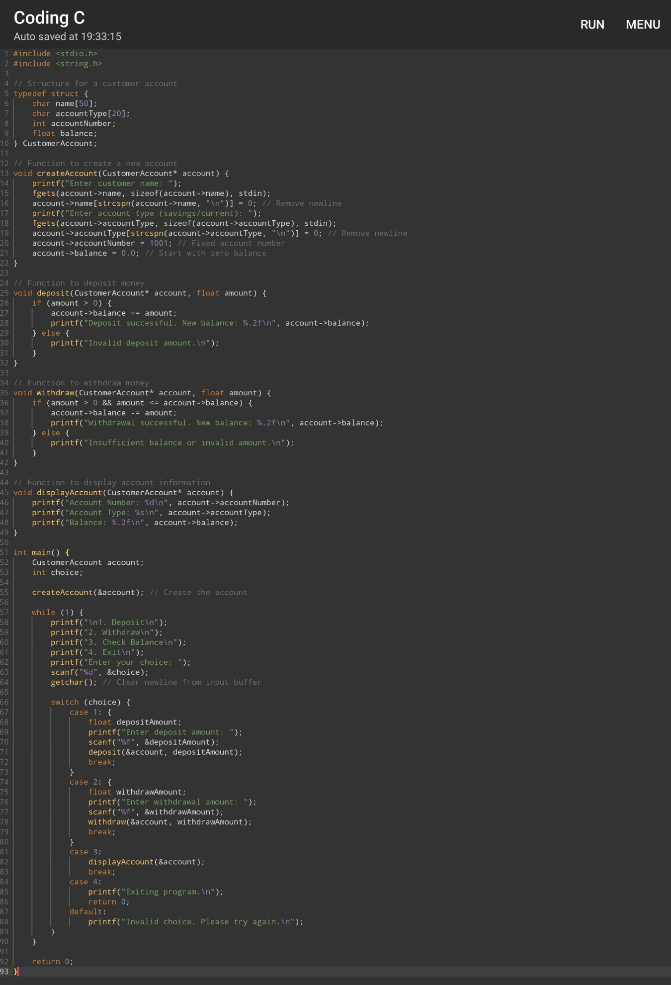
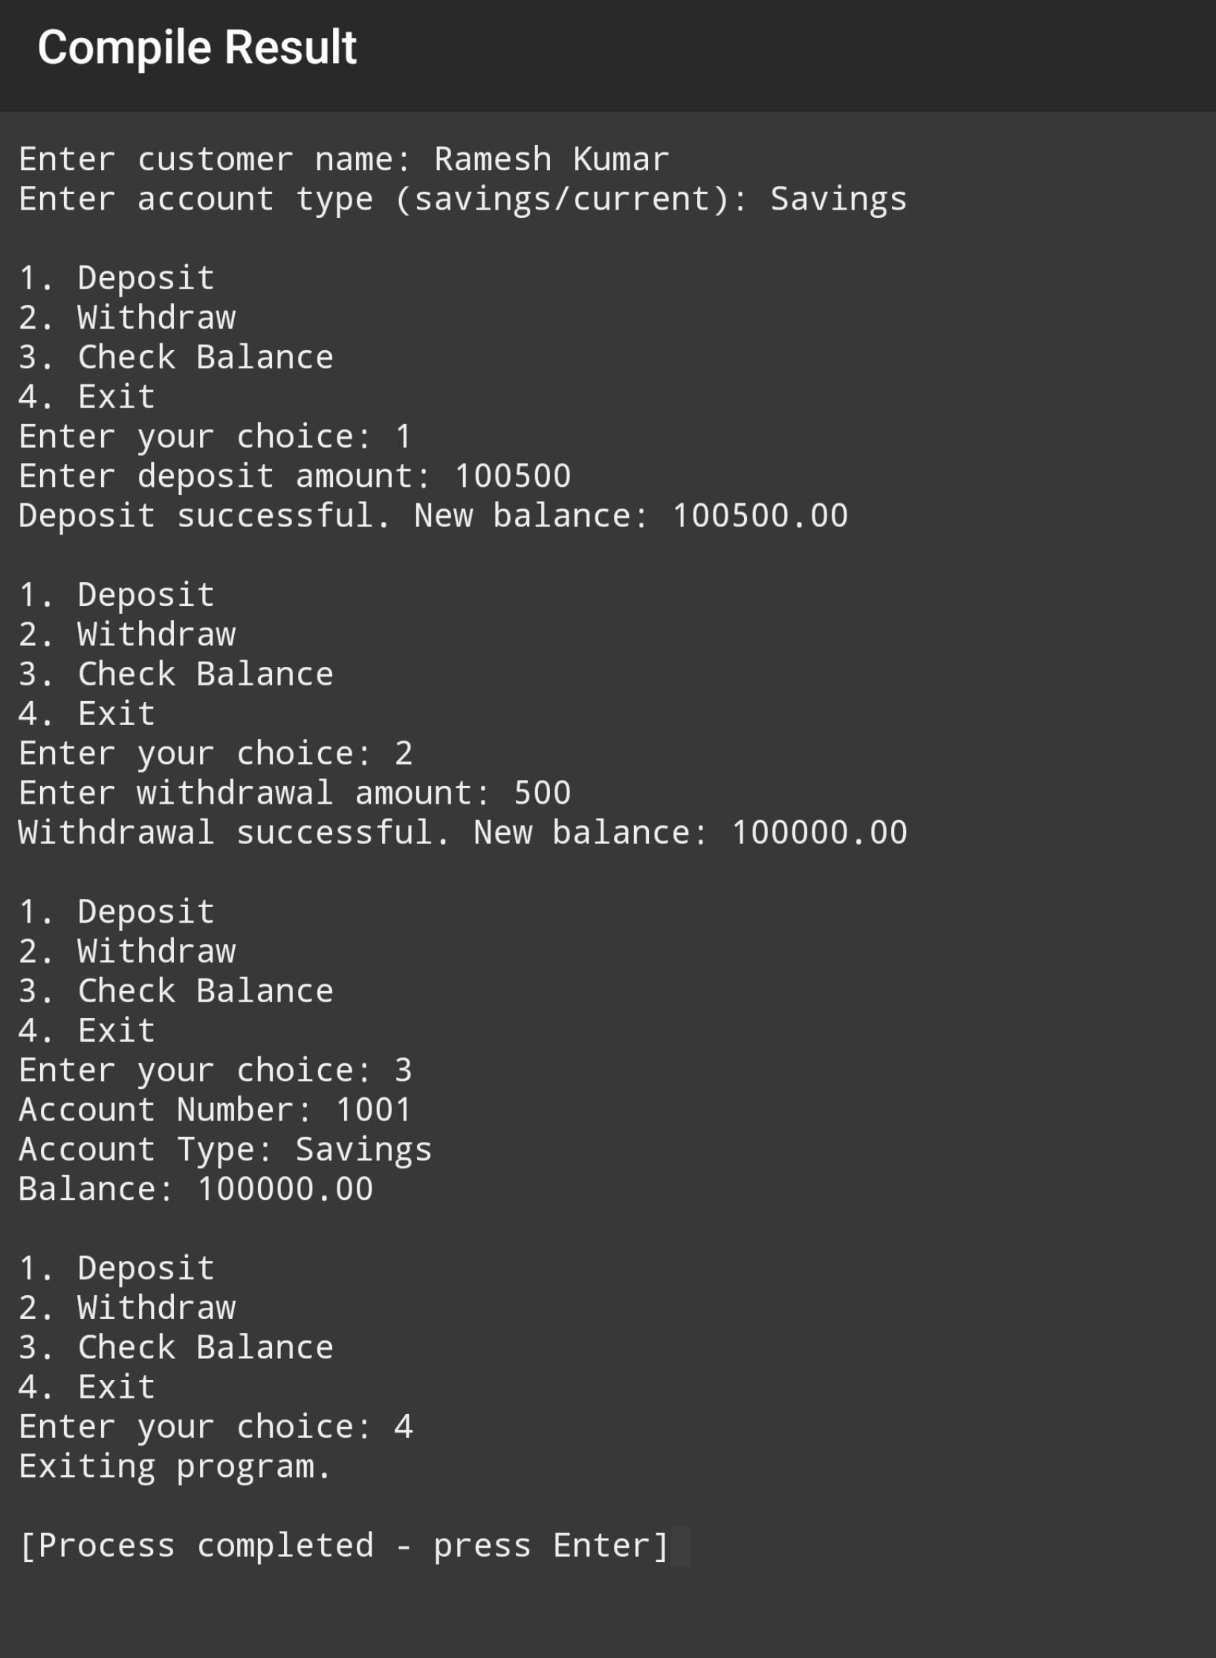
Conclusion
The Bank Management System project demonstrates a foundational approach to managing customer accounts through a simple console application. By leveraging structured programming concepts, the system allows for basic banking operations such as account creation, deposits, withdrawals, and balance inquiries.

Key highlights of the project include:

1.Simplicity and Usability: The user interface is straightforward, enabling users to easily navigate through their banking options.

2.Modular Design: Functions are clearly defined, promoting code reusability and maintainability.

3.Scalability Potential: While the current implementation manages a single account, the architecture allows for future enhancements, such as supporting multiple accounts, generating unique account numbers, and implementing file storage for persistent data.

4.Foundation for Further Development: This project serves as a springboard for more complex features, including transaction histories, account transfers, and advanced input validation, making it an excellent starting point for students and developers interested in software development and financial applications.

In summary, the Bank Management System effectively showcases fundamental programming techniques while highlighting areas for improvement and further development, making it a valuable educational tool.

Summary of the Bank Management System Project

The Bank Management System is a console application implemented in C that facilitates basic banking operations for a single customer account. The system allows users to:

1. **Create an Account**: Users can input their name and account type (savings or current), initializing a new account with a fixed account number and a zero balance.

2. **Deposit Funds**: Users can deposit money into their account, with the system ensuring that only valid amounts (greater than zero) are accepted.

3. **Withdraw Funds**: Users can withdraw money, provided they have sufficient balance. The system checks for both the amount's validity and the account's current balance before processing the withdrawal.

4. **View Account Information**: Users can display their account details, including the account number, type, and balance.

The code employs a structured approach using a `CustomerAccount` data structure, with functions dedicated to each operation, promoting modularity and ease of maintenance. Although the application is currently limited to managing a single account, it lays the groundwork for potential enhancements, such as supporting multiple accounts and adding data persistence.

Overall, this project serves as a practical introduction to basic banking functionality and programming principles, with opportunities for further development and improvement.

Bibliography for the Bank Management System in C Programming

1. **Books**:
- Deitel, P. J., & Deitel, H. M. (2017). *C: How to Program*. 10th Edition. Pearson.
- King, K. N. (2003). *C Programming: A Modern Approach*. 2nd Edition. W. W. Norton & Company.

2. **Online Resources**:
- GeeksforGeeks. (n.d.). C Programming Language. Retrieved from [https://www.geeksforgeeks.org/c-programming-language/](https://www.geeksforgeeks.org/c-programming-language/)
- Tutorialspoint. (n.d.). C – File I/O. Retrieved from [https://www.tutorialspoint.com/c_standard_library/c_function_fopen.htm](https://www.tutorialspoint.com/c_standard_library/c_function_fopen.htm)
- C Programming. (n.d.). Retrieved from [https://www.learn-c.org/](https://www.learn-c.org/)

3. **Research Papers**:
- Kaur, J., & Singh, R. (2016). “A Review of Banking Management System.” *International Journal of Computer Applications*, 139(10), 36-41.

4. **Standards**:
- ISO/IEC. (2011). *Programming Language C: ISO/IEC 9899:2011*. International Organization for Standardization.

5. **Documentation**:
- C Standard Library Documentation. (n.d.). Retrieved from [https://en.cppreference.com/w/c](https://en.cppreference.com/w/c)

These resources cover essential concepts in C programming and banking systems, providing a solid foundation for understanding and developing a Bank Management System.

